ISYE 6740 – Spring 2025
Final Report

Team Member Names:
Project Team 129
Ricky Wiryopranoto (GT ID: 903949033)
Ram Charan Singh (GT ID: 903860201)

Project Title: Beyond the Pokédex: How AI Learns to Identify Species

Separation of work:
Ricky Wiryopranoto: Research, unsupervised model, supervised model, report write-ups
Ram Charan Singh: Research, unsupervised model, report write-ups

Problem Statement
Classifying animals into distinct taxonomic groups has long been a complex challenge in biology. Species identification relies on a combination of morphological traits, genetic data, and ecological factors, yet distinguishing closely related species or identifying organisms based on visual attributes alone remains difficult. Variability in colour patterns, shapes, and textures adds another layer of complexity, making manual classification prone to subjectivity and errors.

With advancements in data science and machine learning, automated classification methods have emerged as powerful tools for analysing visual characteristics and assigning categorical labels. Image classification models can learn patterns from large datasets and recognize subtle distinctions that may not be immediately apparent to the human eye. These techniques have been widely applied in fields such as biodiversity research, wildlife monitoring, and species discovery.

Inspired by these real-world challenges, this project explores whether machine learning models can accurately predict a Pokémon’s typing based on its coloured image. Pokémon types, such as Fire, Water, and Grass, serve as predefined categories akin to biological classifications. By training different image classification models on Pokémon artwork, we aim to analyse how well visual features such as colour schemes, textures, and shapes, align with these categories.

Beyond Pokémon classification, this research has broader implications for biological taxonomy and species identification. If models can effectively map visual patterns to Pokémon types, similar methodologies could be applied to real-world animals. This could aid in species classification, discovering likenesses between different organisms, or even refining taxonomic groupings based on visual attributes.

Ultimately, this study seeks to evaluate the performance of different model architectures, assess their interpretability, and bridge the gap between fictional and real-world classification systems. The findings could offer insights into how visual features contribute to categorical distinctions in both artificial and real-world domains.

Dataset Construction and Preprocessing
The dataset used in this project consists of 809 Pokémon spanning across the first seven generations. For each Pokémon, the dataset includes:
- Name
- Primary Type (Type1)
- Secondary Type (Type2)
- Filename linking to its corresponding sprite image
The sprite images were sourced through PokeAPI, a publicly available and Pokémon database. Using the API, the relevant attributes (names, typings, and image URLs) were scraped, and the associated sprite images were downloaded and stored locally. Each image is in PNG format with a 120×120 pixel resolution, containing RGBA (Red, Green, Blue, Alpha) colour channels.
To prepare the dataset for feature extraction, we discarded the alpha channels and retained the RGB channels to ensure uniformity and avoid introducing noise during model training.

Feature Extraction
To explore how Pokémon might visually cluster based on their appearance, multiple feature extraction strategies were employed. Each method aimed to capture different aspects of the sprites, ranging from raw pixel-level information to high-level abstract representations of shapes, textures, and colours. This multi-pronged approach allowed for a comprehensive analysis of the visual properties embedded in the sprite images.

Raw Pixel RGB Vector Features
The first feature extraction method involved utilizing the raw pixel data directly from the sprite images. Each 120×120 pixel sprite was flattened into a one-dimensional vector by sequentially concatenating its RGB values. This resulted in a 43,200-dimensional vector (120 × 120 × 3 channels) for each Pokémon. This method serves as a baseline, capturing the complete colour and spatial information of each sprite in its most unprocessed form. While this technique preserves every detail, it also includes background noise and does not emphasize important visual structures or patterns, which may reduce the efficacy of the models.

Pretrained ResNet 18 Features
The second method leveraged a pretrained ResNet-18 convolutional neural network to extract rich visual features. Each sprite image was resized to 224×224 pixels to match ResNet's input specifications. Images were also normalized using the standard ImageNet mean and standard deviation values to ensure compatibility with the pretrained network weights. The processed images were then passed through the network, and 512-dimensional feature embeddings were extracted from the penultimate layer. These embeddings are designed to capture high-level semantic information, such as shapes, textures, object boundaries, and more complex visual features. Unlike raw pixels, the ResNet embeddings are hierarchical, meaning they encode both local patterns (e.g., edges, corners) and global patterns (e.g., overall body shape), which might prove impertinent to distinguishing between different Pokémon based on visual similarity.

Dimensionality Reduction
Given the high dimensionality of the extracted features, dimensionality reduction techniques were employed to enable both visualization and improved clustering performance.

Principal Component Analysis (PCA)
The first method applied was PCA, a classical linear technique for dimensionality reduction. PCA was applied to both features, and the number of principal components was determined by setting a variance retention threshold of 95%. Based on the explained variance curve, 201 principal components were required for the 512-dimensional ResNet features and 351 principal components were required for the raw pixel RGB vector features. Finally, PCA was also used to visualize the clusters in the model by further projecting the features down to 2 principal components.

Uniform Manifold Approximation and Projection (UMAP)
In addition to PCA, UMAP was also explored for dimensionality reduction, especially as a precursor to density-based clustering. UMAP was chosen for its ability to preserve both local and global structure better than PCA as it can model nonlinear relationships as compared to PCA which relies on linear relationships, making UMAP more suitable for complex image features. It also maintains true neighbor relationships in the lower dimensional space, a property crucial for DBSCAN. Hyperparameters (number of neighbors and minimum distance) were tuned to balance the preservation of local detail and global manifold structure before being fed into DBSCAN.

Methodology

A two-pronged approach was adopted for this project, applying both supervised and unsupervised learning techniques to the same dataset.

For supervised learning, a convolutional neural network (CNN) was developed and trained to classify Pokémon images into their respective primary types.

For unsupervised learning, six different models were explored. These models combined two different feature extraction methods (raw pixel RGB vectors and pretrained ResNet18 features), dimensionality reduction techniques (PCA and UMAP), and clustering algorithms (K-Means and DBSCAN). The different combinations are summarized in Figure 1 below.

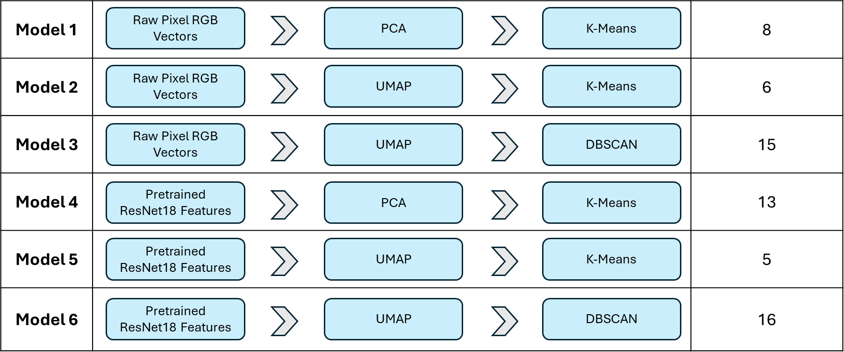
Figure 1: Summary of the six models used for unsupervised learning

5.1 Unsupervised Learning
A total of six models were developed and evaluated, each incorporating different combinations of feature extraction, dimensionality reduction, and clustering techniques. The goal was to explore how various visual representations and unsupervised learning methods could reveal meaningful groupings among Pokémon based on their sprite appearances.

For all models utilizing K-Means clustering (Models 1, 2, 4, and 5), the selection of the optimal number of clusters (k) was carefully determined using both the elbow method and silhouette scores to ensure balanced and meaningful clustering results. The final value of k chosen for each model was made by giving preference to k values near the elbow point while also selecting values of k that achieved relatively high Silhouette Scores.
For models utilizing DBSCAN clustering (Models 3 and 6), a systematic approach was adopted to tune the key hyperparameters: epsilon (ε) and minimum samples (min_samples). The chosen (ε, min_samples) pairs were those that produced clearly separable, meaningful clusters while minimizing the number of points classified as noise. Silhouette Scores were also computed to provide additional validation of cluster quality.
Due to the tuning of each model based on their optimal k values and (ε, min_samples) pairs, each model ultimately produced different sets of clusters as shown in Figure 1.

5.2 Supervised Learning (Show a CNN block diagram if you want)
For supervised learning, a CNN model was extended to classify Pokémon images into all 18 possible primary types. The aim was to build a multiclass image classification model that could identify the primary types of Pokémon based on its visual features alone.

The classification model is built utilizing Keras Functional API and is designed to process 120x120 pixel RGBA images. It starts with three convolutional layers using 8x8 kernels and increasing filter size of 64,128, and 256, each followed by a max pooling layer. These layers allow the model to extract hierarchical features from the images. Ideally, this will allow the model to capture both minute details and patterns.

The final layer is a softmax dense layer with 18 units, corresponding to number of available primary Pokemon types. By configuring the model as such, it allows the model to output a probability distribution over all classes for each input image.

For training, the model was compiled using Adam optimizer on categorical cross-entropy. As for evaluation, we are evaluating the model based on accuracy and multi-class AUC. This will give us insight into model’s capabilities to classify samples into classes.??

Models’ Evaluation

Unsupervised Learning
Since each model produces a different set of clusters and does not inherently align with the true type labels, direct comparison between cluster assignments and the 18 Pokémon typing labels in the dataset is unrealistic. Instead, to evaluate and interpret the clustering quality, we analyze the dominant Pokémon typing composition within each cluster. For each model, we construct a heatmap where:
- Each row corresponds to a discovered cluster.
- Each column corresponds to a Pokémon typing.
- The cell values represent the percentage of Pokémon within the cluster that belong to each type.
Heatmap Analysis
The results of the heatmap evaluation are shown in Figures 2 to 7 below. While some individual clusters exhibit promising concentration, like for example Model 6 where Cluster 14 shows approximately 60% Normal typing, these results are often accompanied by very small cluster sizes (typically fewer than 10 Pokémon). As a result, clusters with high typing purity tend to arise from outliers or minor groups, rather than representing meaningful large-scale structures within the data. Overall, among all the models tested, Model 4 achieved the most consistent performance, displaying relatively higher type purities across a larger number of Pokémon and more stable cluster distributions. This suggests the following:
- Dataset Limitation
The limited size of the dataset (809 Pokémon) and the inherent class imbalance among Pokémon types (over-representation of Water-types and under-representation of Flying-types) likely constrained the models' ability to form clean, large clusters aligned with specific typings.

- Intrinsic Diversity of Pokémon Designs
Pokémon visual features are highly diverse and multi-faceted. A Pokémon's type is not always strongly reflected in its colour, shape, or texture alone. Many Pokémon share visual similarities across different types (for example Yveltal may look closer to a dragon or flying dark but is primarily a dark type, while some within the same type have very different designs. As a result, purely visual clustering does not always map cleanly onto the semantic typing labels defined by the game designers. This observation highlights the complexity and rich multimodal nature of Pokémon design suggesting that visual features alone are often insufficient proxies for determining a Pokémon’s elemental typing.
Thus, while some structure was discovered through unsupervised learning, the relationship between Pokémon visual features and typing labels appears non-trivial and highly entangled, emphasizing the limitations of purely image-based clustering approaches for determining a Pokémon’s typing.

Emerging Visual Patterns
Despite the overall difficulty in aligning clusters directly with Pokémon typings, several consistent patterns emerged from the clustering results across different models.
First off, we observed that Pokémon with large, prominent wings, tended to cluster together, especially in models utilizing Pretrained ResNet18 Features (Models 4, 5, and 6) suggesting that ResNet18 embeddings are highly sensitive to structural and textural features, such as wing shapes and body outlines, which are captured more effectively as compared to raw pixel information. Similarly, Pokémon with spherical or ball-like body shapes were frequently grouped into the same clusters, again indicating that ResNet18 is adept at recognizing global object shapes and geometry.
Model 4 Cluster 11 Model 5 Cluster 3


In contrast, models based on raw pixel RGB vectors (Models 1, 2 and 3) tended to cluster Pokémon more heavily based on dominant colour themes rather than structural similarity. For example, blue coloured Pokémon and pink coloured Pokémon were more likely to be grouped together. This is because raw pixel RGB vector features primarily encode low level colour distribution without any understanding of higher order shapes, edges, or textures. Thus, while useful for detecting broad colour groupings, raw RGB vectors lack the spatial awareness that convolutional models like ResNet18 inherently capture.
Model 2 Cluster 0 Model 1 Cluster 6

Overall, these observations reinforce the idea that feature extraction method heavily influences the type of visual similarity captured, with raw RGB focusing on colour palettes, and deep CNN features like ResNet18 focusing more on object form, texture, and complex visual patterns.

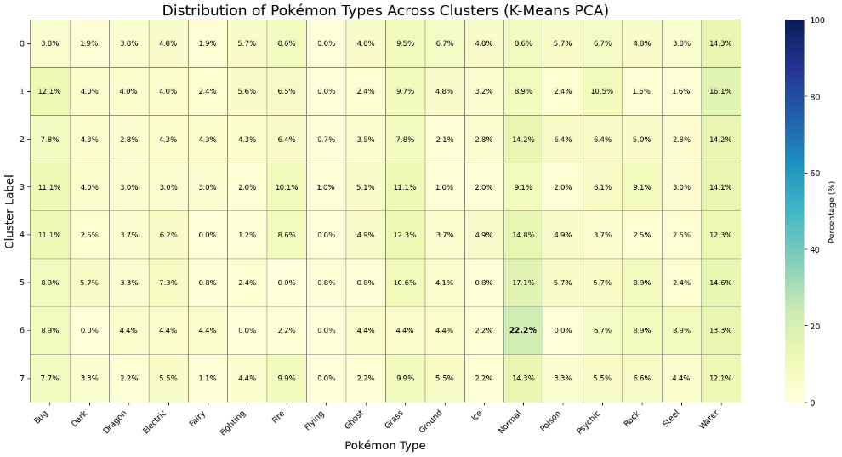
Figure 2: Distribution of Pokémon Types Across Clusters for Model 1
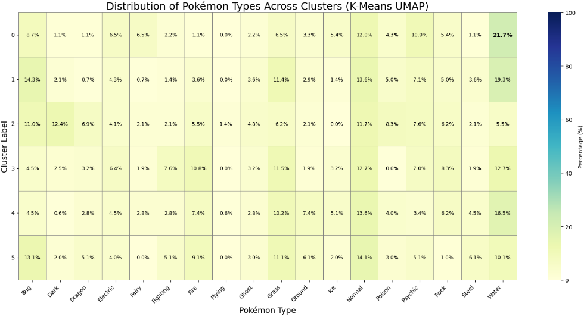
Figure 3: Distribution of Pokémon Types Across Clusters for Model 2
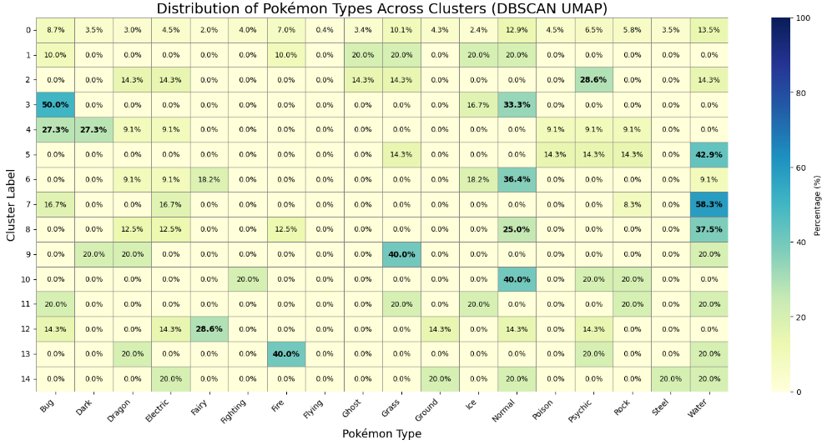
Figure 4: Distribution of Pokémon Types Across Clusters for Model 3

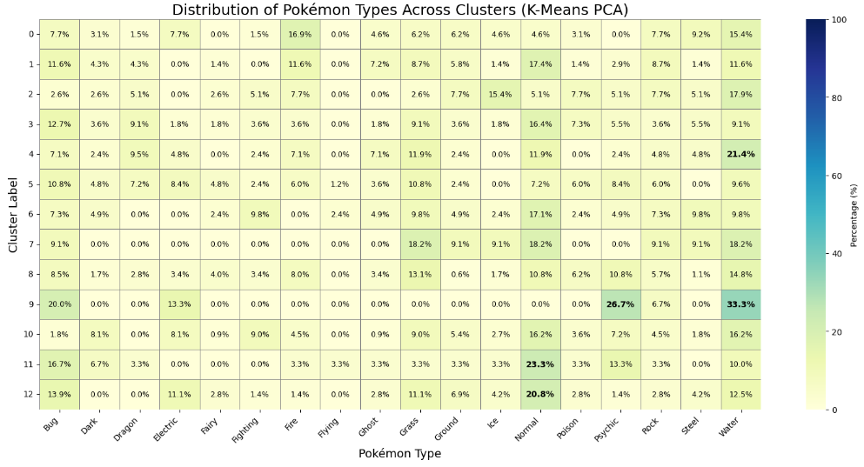
Figure 5: Distribution of Pokémon Types Across Clusters for Model 4

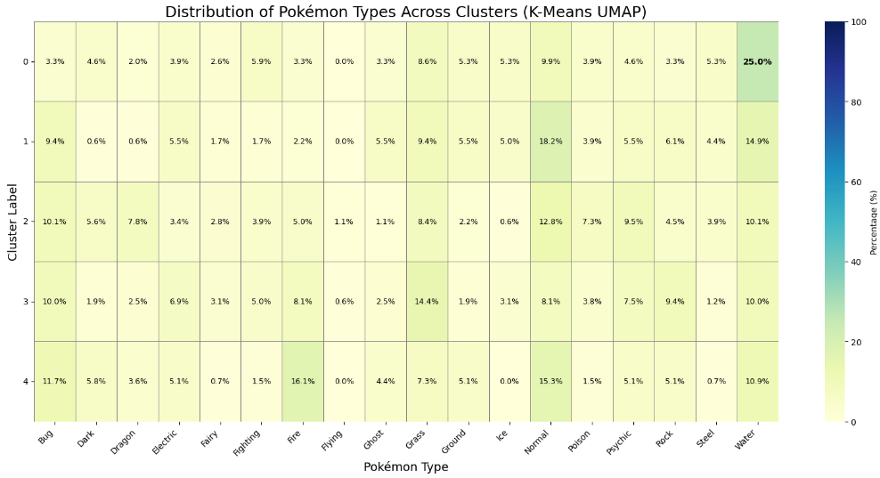
Figure 6: Distribution of Pokémon Types Across Clusters for Model 5

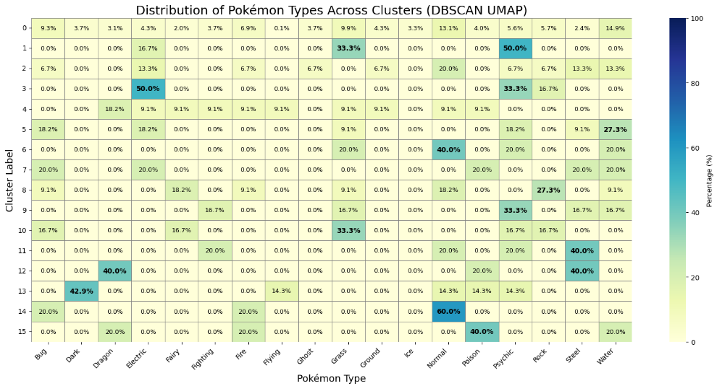
Figure 7: Distribution of Pokémon Types Across Clusters for Model 6

Supervised Learning

The model's performance is summarized in Figure 8 below.

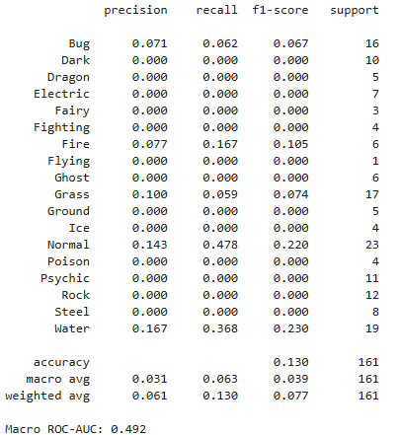
Figure 8: CNN Model Performance
Overall, the model significantly underperforms achieving an accuracy of only 13% and a macro F1-score of 0.039. The macro F1-score, which averages the F1-scores across all classes equally, indicates that the model has very limited ability to correctly classify Pokémon types. While there are relatively better recall scores for the "Normal" and "Water" types at 0.478 and 0.368 respectively, the recall for most other types is 0. Furthermore, the macro ROC-AUC score is 0.492. Macro ROC-AUC measures the model's ability to rank predictions across all classes by averaging one-vs-rest ROC-AUC scores and a value near 0.5 suggests performance close to random guessing, further highlighting the model’s inadequate ability to distinguish between types.

These results are consistent with the findings discussed in 5.1, where other models similarly struggled. The poor performance can largely be attributed to two key factors being class imbalance and limited data volume. With few examples per class, the model may not be able to extract sufficiently distinctive features from the sprites. Additionally, the lack of diverse image data (such as different angles or higher-resolution images) likely hampers the model's ability to generalize across all Pokémon types.

- Project Conclusion and Future Work
In this project, we investigated the feasibility of classifying Pokémon types using machine learning models based solely on sprite images. Both unsupervised and supervised learning approaches were explored across multiple feature extraction strategies and clustering techniques.
The results demonstrated that purely visual features, whether raw pixel values or deep CNN embeddings, are often insufficient to fully capture the semantic typing labels assigned to Pokémon. While certain visual traits were detectable, the relationship between appearance and type is complex, entangled, and influenced by design choices beyond simple morphology or colour.
The supervised CNN model achieved limited success, with a classification accuracy of 13% and a macro-F1 score of 0.039, underperforming relative to expectations. Key contributing factors include dataset size limitations, class imbalance across Pokémon types, and the lack of richer feature modalities.
Future work could consider several extensions to improve results:
- Data Augmentation: Future work can apply rotation, zoom, and flipping to expand the dataset artificially and reduce overfitting.
- Transfer Learning: Future work can use stronger fine-tuning pretrained models such as ResNet50 or DenseNet to leverage stronger feature representations.
- Handling Class Imbalance: Future work can implement weighted loss functions or oversampling techniques to mitigate bias toward dominant classes.
Overall, this study highlights both the potential and the limitations of using visual based machine learning for categorical classification tasks, particularly when visual signals are subtle, ambiguous, or loosely related to semantic categories.

References
[1] Chirra, V. R. R., Syeda, A., Kolla, N., Ghanta, N., & Muvva, S. (2023). Pokémon image classification using transfer learning.
https://www.researchgate.net/publication/370617981_Pokepedia_Pokemon_Image_Classification_Using_Transfer_Learning

[2] Fujisawa, T., Noguerales, V., Meramveliotakis, E., Papadopoulou, A., & Vogler, A. P. (2023). Image-based taxonomic classification of bulk insect biodiversity samples using deep learning and domain adaptation.
https://www.researchgate.net/publication/366888962_Image-based_taxonomic_classification_of_bulk_insect_biodiversity_samples_using_deep_learning_and_domain_adaptation

[3] Stiller, S., Dueñas, J. F., Hempel, S., Rillig, M. C., & Ryo, M. (2023). Deep learning image analysis for filamentous fungi taxonomic classification: Dealing with small data sets with class imbalance and hierarchical grouping.
https://www.researchgate.net/publication/371832069_Deep_learning_image_analysis_for_filamentous_fungi_taxonomic_classification_Dealing_with_small_data_sets_with_class_imbalance_and_hierarchical_grouping

